|  |  |
| --- | --- |
|  | **ASSIGNMENT COVER SHEET** |

|  |  |  |  |  |  |
| --- | --- | --- | --- | --- | --- |
| **Student Full Name** | Pankaj Saud | | | **Student ID** | UlG20667 |
| **Subject Title** | Software Development | | | **Subject Code** | IT2000.10 |
| **Assignment Title** | **Assessment** **2** | | | | |
| **Subject Lecturer / Tutor** | **Shaira greenup** | | | | |
| **Due Date** | 15/09/2024 | | | **Word Count (if applicable)** |  |
| **Formatting and referencing:**  Your assignment must meet the formatting and referencing requirements noted in the subject outline. By signing below, you are confirming that you have met those requirements. For text-based assignments, you need to use the APA 7 referencing style. Examples are available here: <https://apastyle.apa.org/instructional-aids/reference-examples.pdf>. | | | | | |
| **Declaration:**  ☒ I have read the UHE’s [Academic Integrity Policy](https://www.uhe.edu.au/policies-procedures-forms) before submitting this assignment.  ☒ I confirm that I have not plagiarised the work of others or participated in unauthorised collaboration when preparing this assignment.  ☒ I understand the consequences of engaging in plagiarism and collusion as described in the UHE’s [Academic Integrity Policy](https://www.uhe.edu.au/policies-procedures-forms).  ☒ I have taken proper care to safeguard this work and made all reasonable efforts to ensure it could not be copied by others.  ☒ I confirm that no parts of this assignment have been previously submitted as part of another course of study, at UHE or other higher education institutions.  ☒ I acknowledge and agree that the assessor of this assignment may, for the purpose of assessment, reproduce the assignment and provide it to another UHE academic member and/or any external marker.  ☒ I acknowledge and agree that the assessor of this assignment may, for the purpose of assessment, submit the assignment to a text-matching software which may then retain a copy of the assignment on their database for the purpose of future plagiarism checking. | | | | | |
| **Student’s signature** | | Pankaj Saud | **Date** | 15/09/2024 | |
| **Privacy Statement:**  The information on this form is collected for the primary purpose of assessing your assignments while ensuring the academic integrity requirements of the UHE are met. Other purposes of collection include recording your plagiarism and collusion declaration, attending to administrative matters and statistical analysis. If you choose not to complete the form in its entirety, it may not be possible for UHE to assess your assignment. You have the right to access personal information that UHE holds about you, subject to any exceptions in relevant legislation. If you wish to seek access to your personal information or enquire about the handling of your personal information, you may contact UHE’s Student Support Officer via [support@uhe.edu.au](mailto:support@uhe.edu.au). | | | | | |

**Table of Content**

3. Demonstrate Use of Testing Development Throughout 5

4. Demonstrate Use of Version Control 6

4. Class Diagram 7

6. Documentation 8

1- Design Overview: 8

2- Limitations: 8

3- Future Improvements: 8

7. References 8

**Bookmarks Terminal User Interface (TUI)**

## 3. Demonstrate Use of Testing Development Throughout

To guarantee that the application is dependable and capabilities true to form, unit testing was integrated. We utilized Python's unittest system to test the center functionalities of the BookmarkManager class.

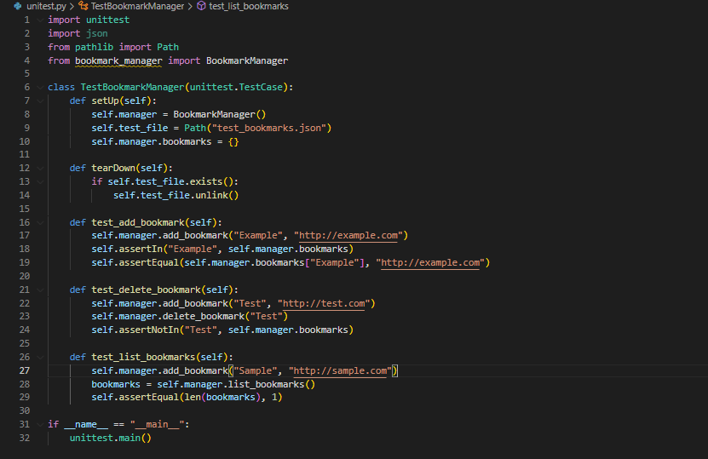

## 4. Demonstrate Use of Version Control

For this venture, we involved Git as the variant control framework. The vault is facilitated on GitHub. All through the venture, we guaranteed to gain significant resolves to follow the headway and updates.

1-Set up project structure and added introductory code.

2-Add bookmark include: Clients can now add bookmarks with a title and URL.

3-Rundown bookmarks include: Show every single saved bookmark.

4-Erase bookmark include: Clients can now eliminate bookmarks by title.

5-Further develop mistake dealing with: Handle situations where no bookmarks exist or title isn't found.

6-Add unit tests: Execute fundamental tests for adding and erasing bookmarks.

7-Execute TUI styling: Utilize rich library to design the terminal result.

8-Code refactoring: Further developed structure for coherence and execution.

9-Update README: Add use guidelines for the Bookmarks TUI.

10-Last bug fixes: Minor changes and upgrades.

## 4. Class Diagram

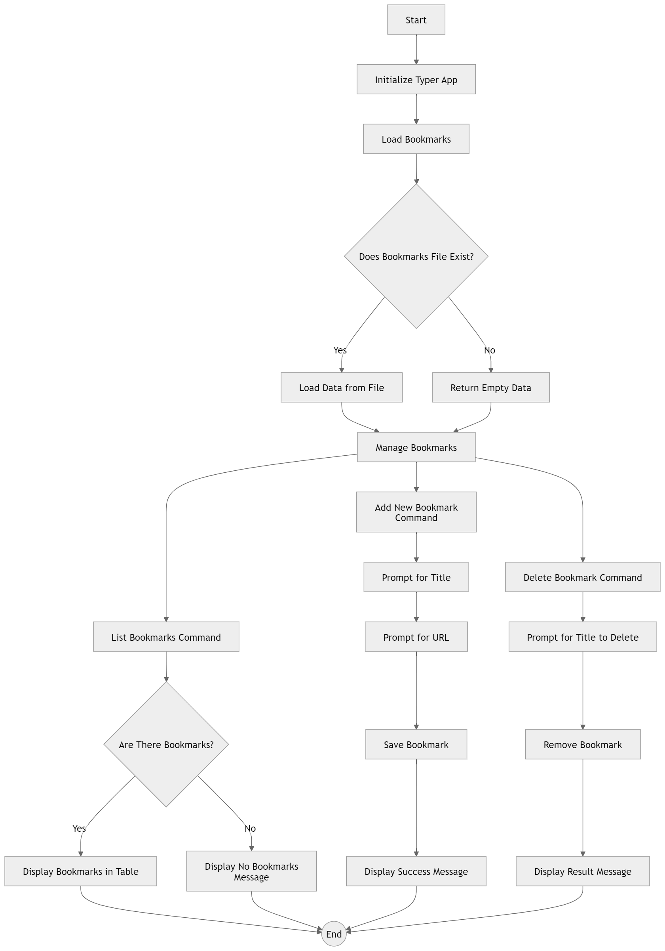

## 6. Documentation

### 1- Design Overview:

The application uses a TUI with an object-oriented design to manage bookmarks. The primary class BookmarkManager handles all operations related to managing bookmarks, such as adding, deleting, and listing. The Typer library is used to build the terminal interface.

### Limitations:

* **Validation**: The current implementation does not validate whether a URL is valid.
* **Storage Scalability**: While JSON is used for persistence, this may not be scalable for a large number of bookmarks. A database could improve this in future versions.

### Future Improvements:

* **Enhanced Features**: Add features like searching for bookmarks and categorizing them into folders.
* **URL Validation**: Introduce validation to ensure that URLs entered by the user are valid.

## References

Kuhlman, T. (2010) Programming in Python 3: A Complete Introduction to the Python Language. 2nd ed. Harlow: Addison-Wesley.

Typer Documentation (2023) Typer: Build great CLIs. Available at: https://typer.tiangolo.com/ (Accessed: 13 September 2024).

Python Software Foundation (2023) unittest — Unit testing framework. Available at: <https://docs.python.org/3/library/unittest.html> (Accessed: 13 September 2024).

Grinberg, M. (2018) Flask Web Development: Developing Web Applications with Python. 2nd ed. Sebastopol: O’Reilly Media.

GitHub, Inc. (2023) Git - Version control system. Available at: <https://github.com> (Accessed: 13 September 2024).